Amogh Garg-2020UCO1688

Anant-2020UCO1693

Daksh Chetiwal-2020UCO1646

Abstract

This project is about making a Blood Bank Management System and includes both Front-End as well as Back-End. Front-End is made using HTML and CSS and Back-End is made using MYSQL and PHP

COCSC05-DBMS

PROJECT FILE

# **E-R DIAGRAM:**

# RELATIONAL SCHEMA:

DONOR (Donor_ID, First_Name, Last_Name, DOB, DPhone)  
DONATED_BLOOD (Donor_ID, DOD, Blood_Group, Amt_Donated)  
BLOOD_STOCK (Blood_Group, Amt_Available)  
PATIENT (Patient_ID, PFirst_Name, PLast_Name, PPhone, PDOB)  
RECEIVED_BLOOD (Blood_Group, DOR,Blood_Group, Amt_Received)

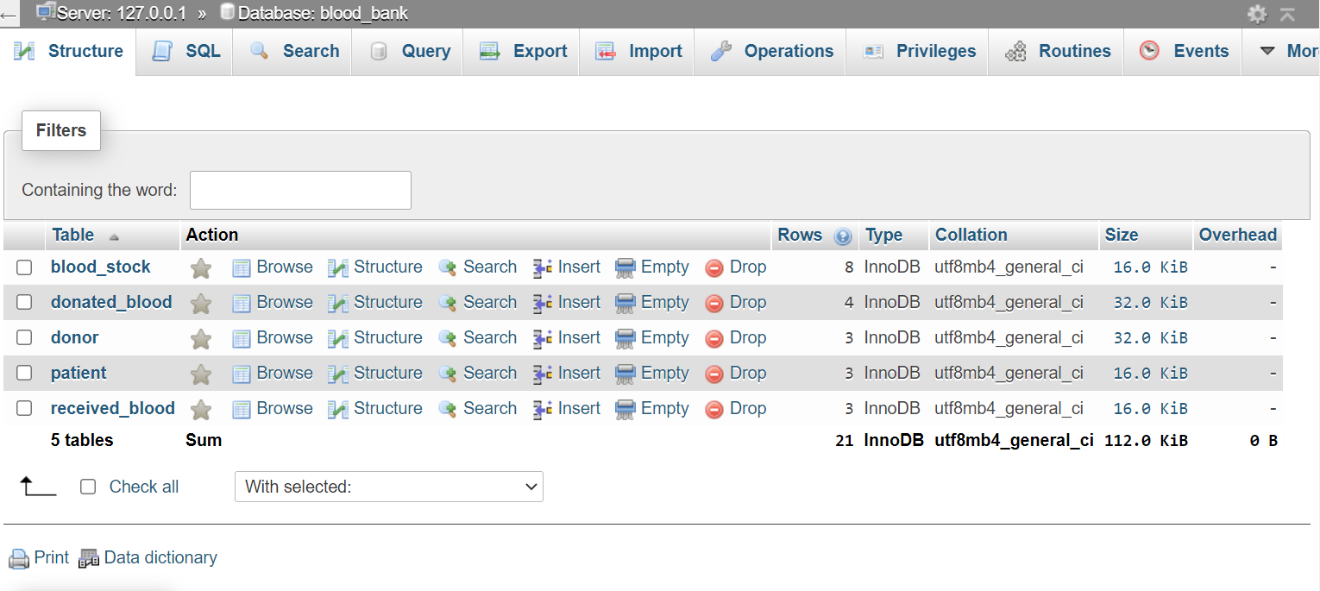

# KEYS AND TRIGGERS:

TABLE DONOR: Primary key is Donor_ID.  
TABLE DONATED_BLOOD: Donor_ID is the Foreign-Key in this table.  
TABLE BLOOD_STOCK: Blood_Group is the Primary-Key.  
TABLE PATIENT: Patient_ID is the Primary-Key.  
TABLE RECEIVED_BLOOD: Patient_ID is the Foreign-Key in this table.

There are 3 triggers which have been implemented in our database and are as follows:  
1. First trigger is to update Amt_Available in Blood_Stock when inserting data in Donated_Blood table that is after donation has been done.  
2. Second trigger is to update Amt_Available in Blood_Stock when inserting data is Received_Blood that is after receiving blood from blood-bank.  
3. Third trigger is to check whether the requested amount of blood is available in the blood bank or not. If not available request to receive blood would be denied.  
**Added Later:** A trigger to ensure that donor’s age is greater than 18 years.

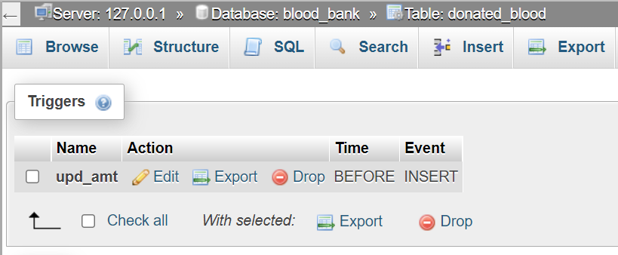

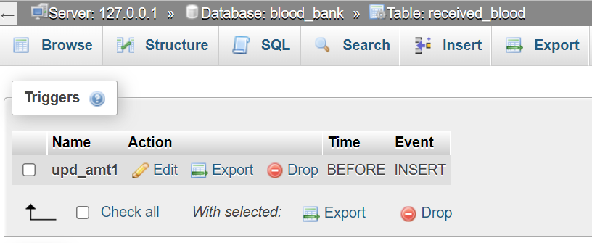FUNCTIONALITIES: 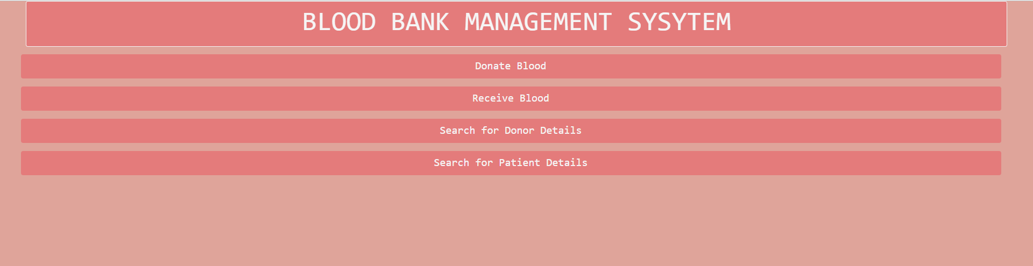

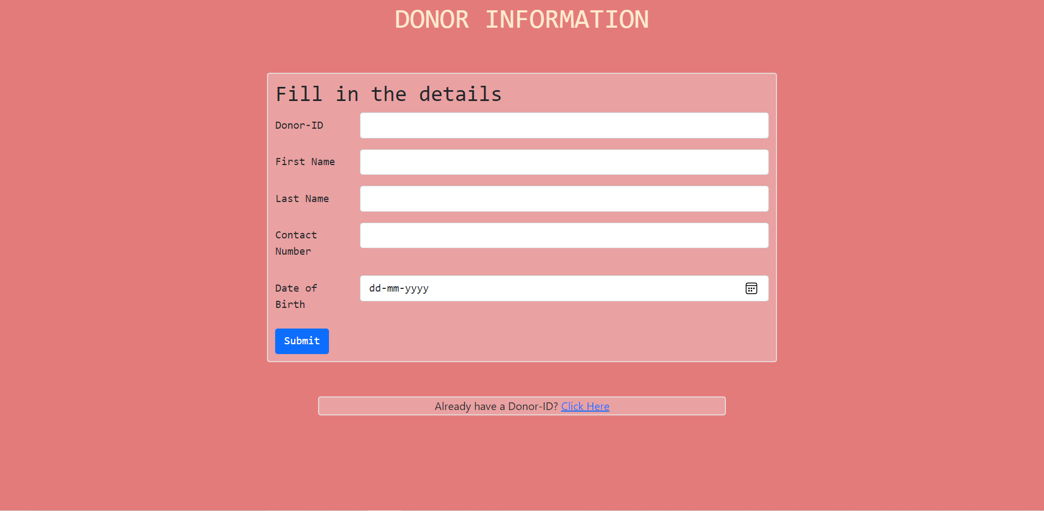  
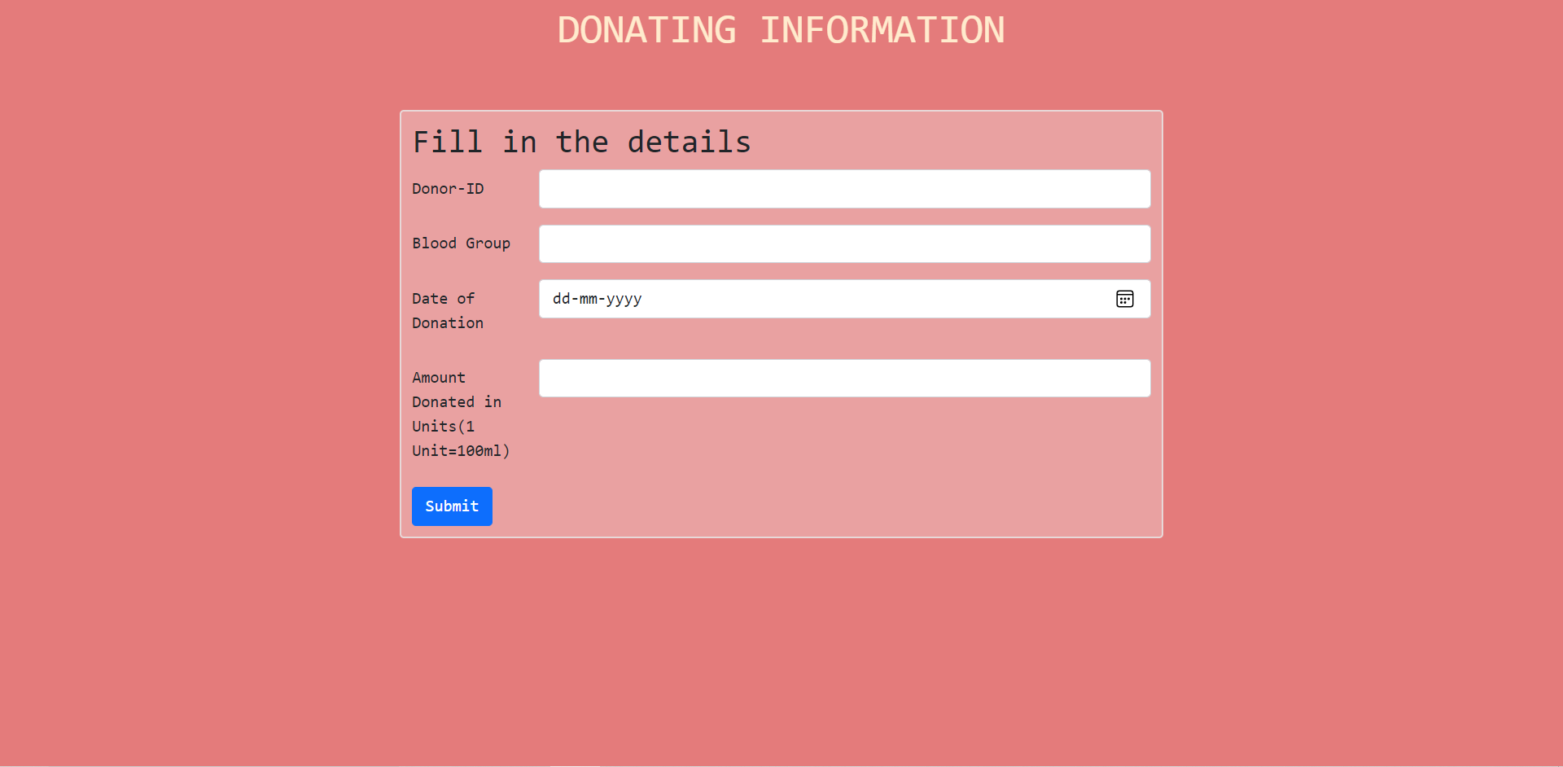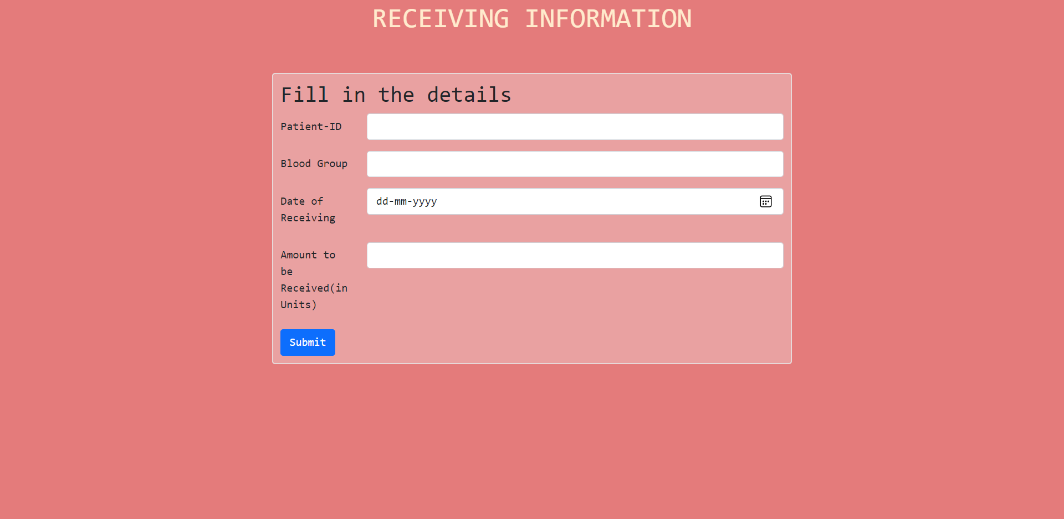

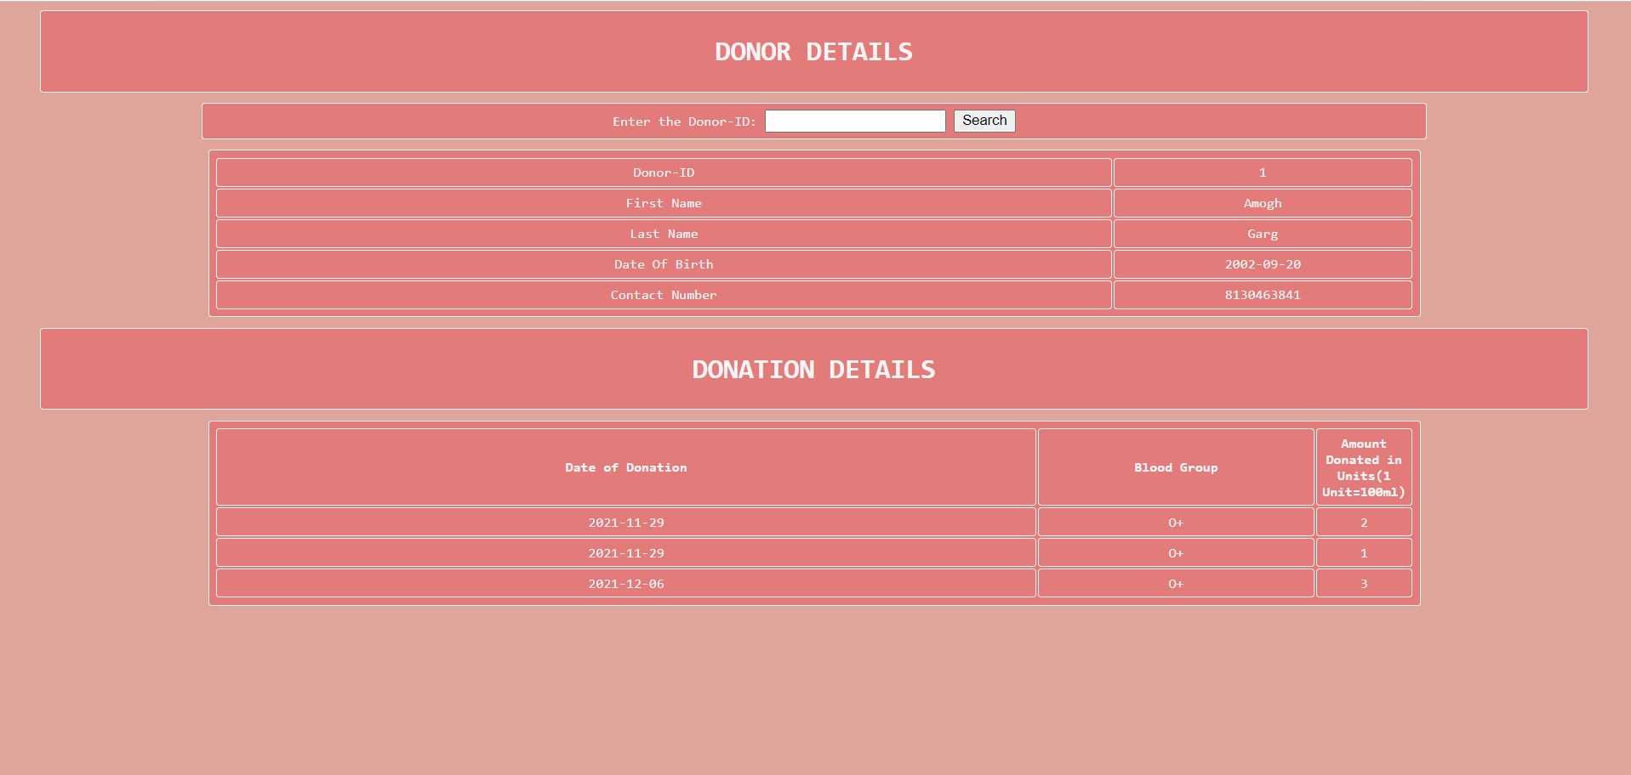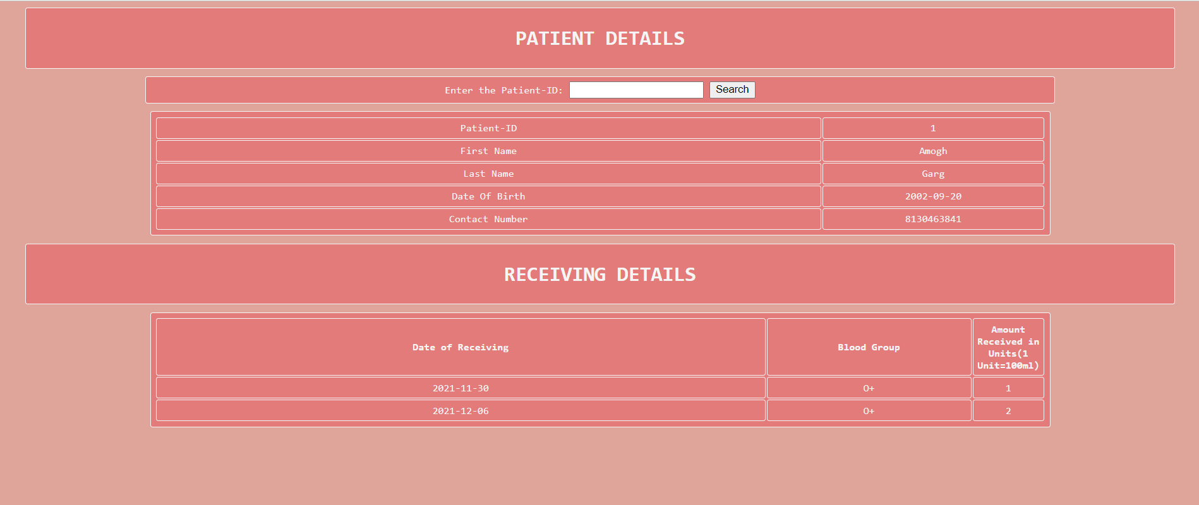

# TABLE DATA:

DONOR:

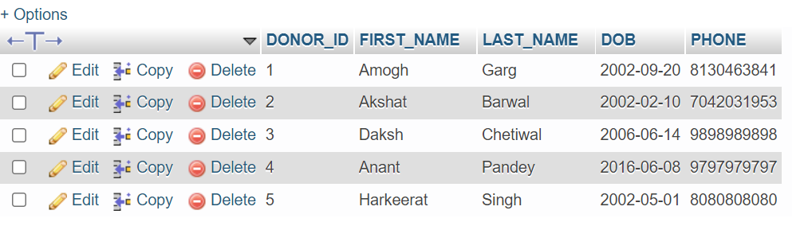  
DONATED_BLOOD:  
 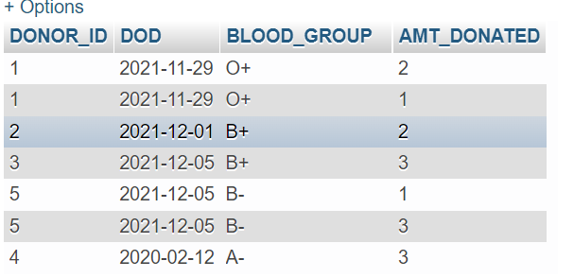  
BLOOD_STOCK: 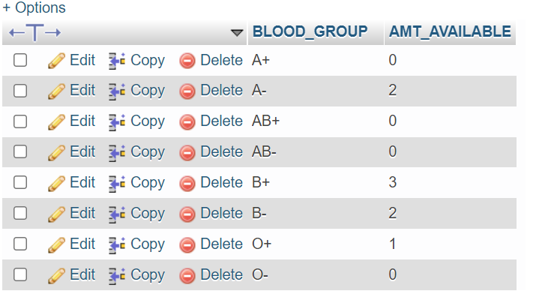  
PATIENT:

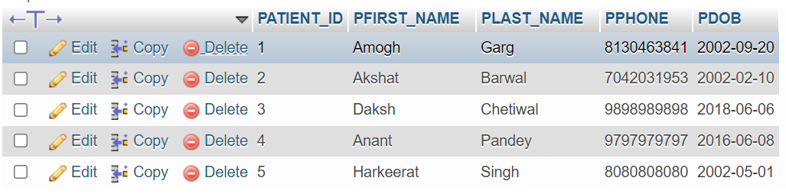  
RECEIVED_BLOOD: 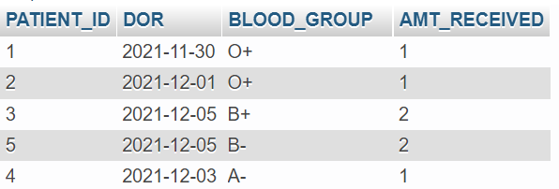

# LINK OF ENTIRE CODE AND DEMO VIDEO OF THE APPLICATION:

<https://drive.google.com/drive/folders/15OltIl3bKvFficvweMsMZQaGziXuiG74?usp=sharing>